Upload THESIS to NEPTUN Study system
To upload a thesis, you need a thesis topic with the status "Under consultation" or "To be uploaded". This can be found in the Neptun Study System under Studies / Thesis/Thesis topic submission:

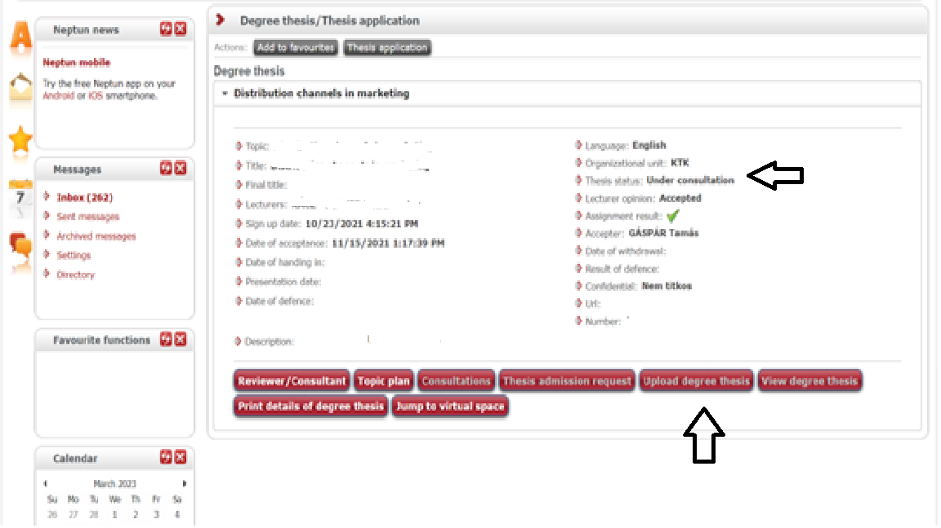
If you do not see the ones indicated, please submit Application form for change of thesis topic to the Study Department (certified by the supervisors).

The size of the thesis file must not exceed 10 MB and the format must be PDF.
The file naming scheme is as follows: NEPTUNCODE_TH.PDF, where NEPTUNCODE is replaced by the student's own NEPTUN code, in all capital letters.
Be sure to upload the final version! If necessary, you can modify the upload before the deadline.
You can submit the thesis file by clicking on the "Upload degree thesis" button under the thesis topic in the Studies / Degree thesis / Thesis application menu.
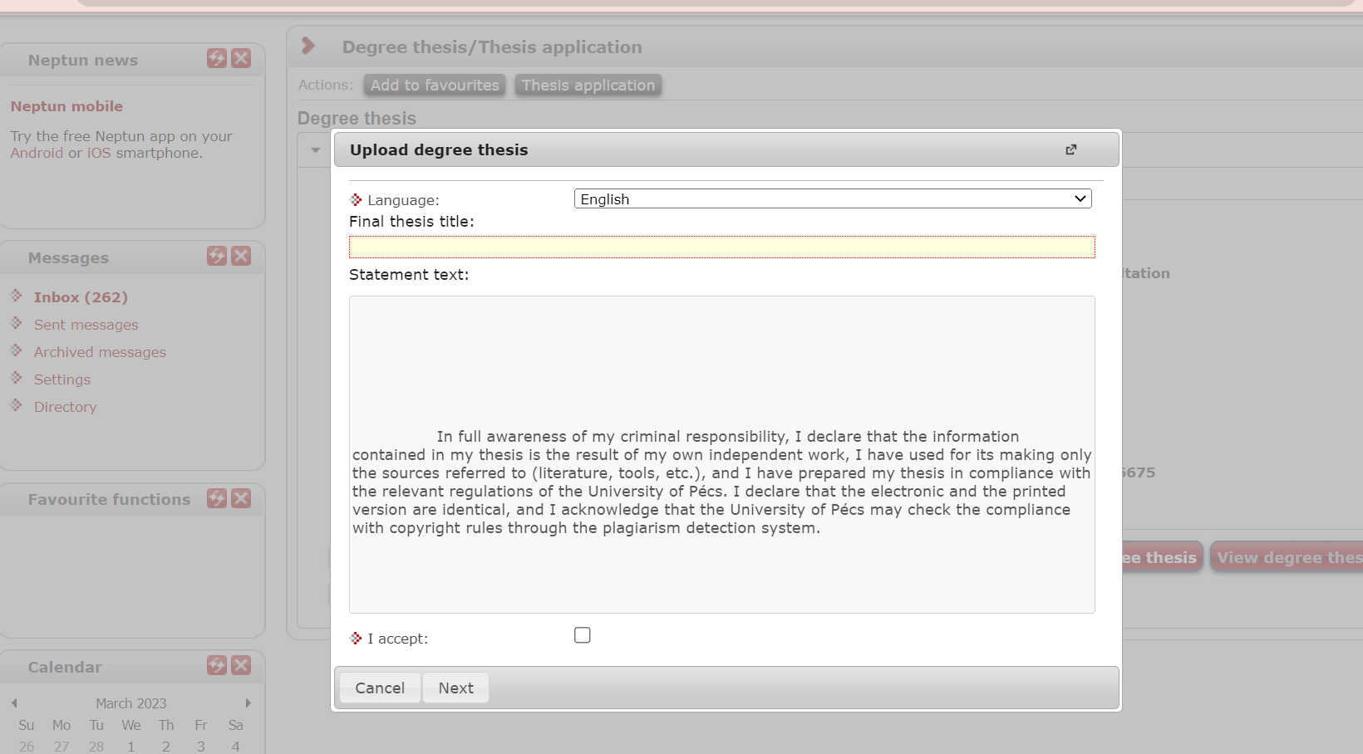

When you upload your thesis, you must declare that it is your own work by ticking a box to replace the previous declaration of authenticity.

