Guide to using the equivalency tables
TIP
Before you start browsing the course portfolio of partner universities, we suggest you log in to your Neptun account, go to Studies, then select your sStudy program, and click the menu point for Uncompleted subjects. Here you can check what subjects you miss from Modules A 1 and 2, and also check how many subjects/credits you miss in modules B and C.
- Click the link below to access the equivalency tables of UPFBE
Equivalency tables
- Select your study program (find Applied Management, Business Administration Management, or Enterprise Development in the starting list. After selecting one of them the application will be fully in English)

- Select FULL TIME in Program Type

- Select planned target country

- Click on the universities one by one.

- Review the course offer. (TIP: Remember to scroll down to the end of the page, to make sure that you have seen all the possibilities. You can check the course offer here. If the list is very short, it is advisable to look around other universities as well)

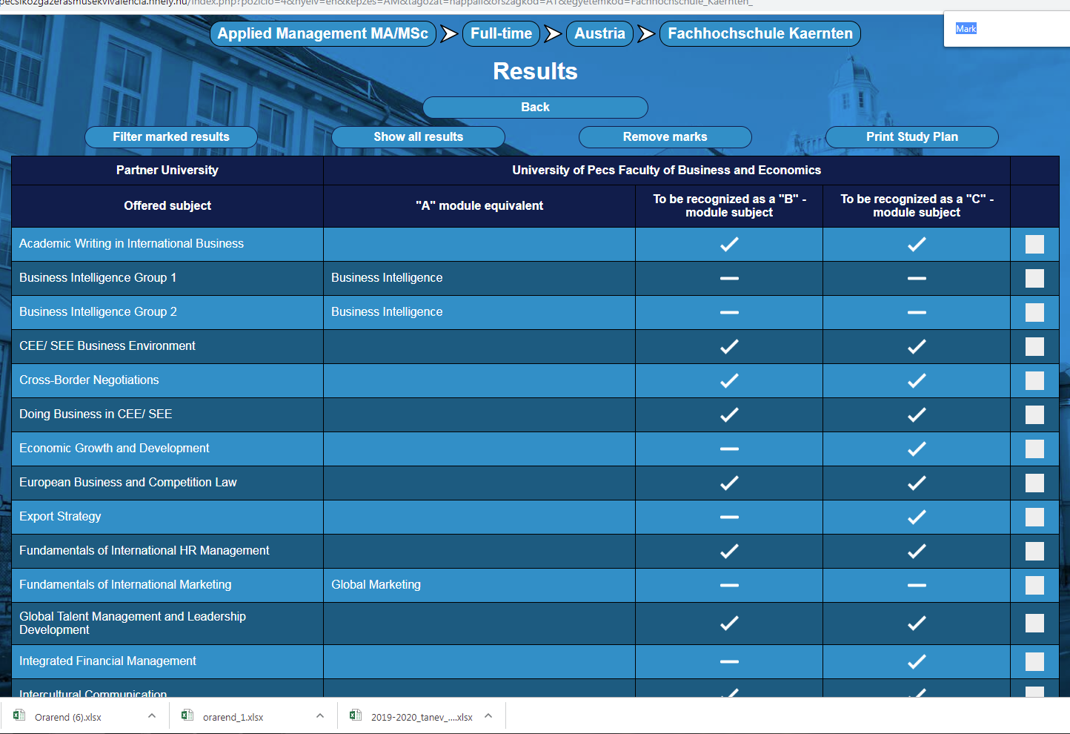

- Based on the information retrieved from Neptun (what A module courses and how many B and C module credits you miss) you can develop your study plan. You can find subject-subject correspondence in case of A-module subjects. If you need to collect B and C-module credits as well, check whether the offered courses are marked by ticks in the 3rd and 4th columns. Select your courses from these.

- Tick the selected subjects in the white boxes (5th column).
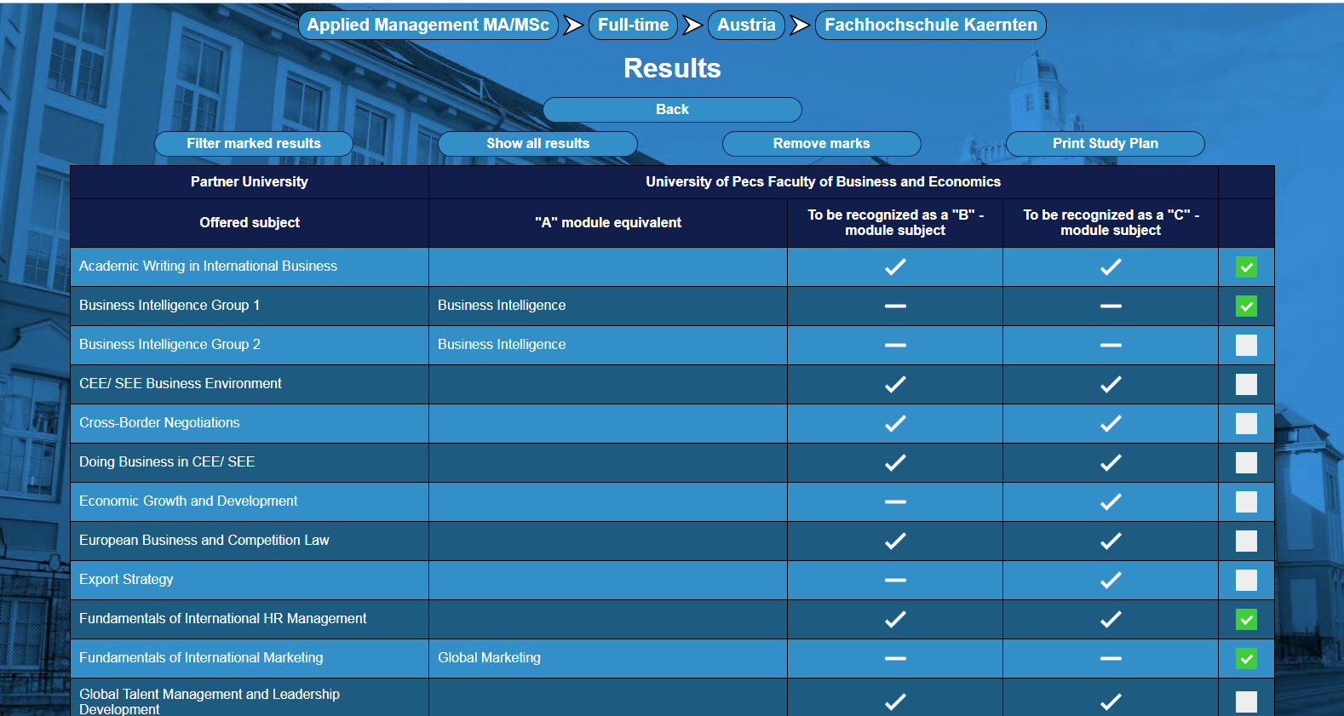

- Klick on “Filter selected marks”

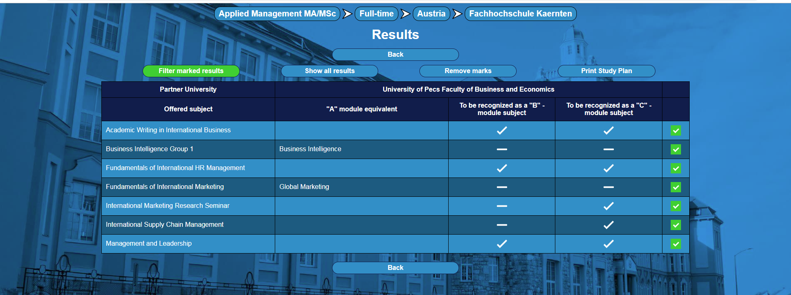

- And finally click on “Print Study Plan”:
Save your printed Study plan (preferably in electronic copy) and attach it as a supplement to FORM I – the request for credit recognition. You will have to submit them together with a copy of your Learning Agreement at the Study Department.

