**Neptun Degree Thesis Registration**

In Neptun study system’s **Studies / Degree thesis** menu item the opportunity for Thesis Application appears.



If you don’t have a thesis topic yet, after pressing **„Thesis application start”**, the topics will be listed. You must choose a period, then at the end of the line you need to click on the „Register” button.

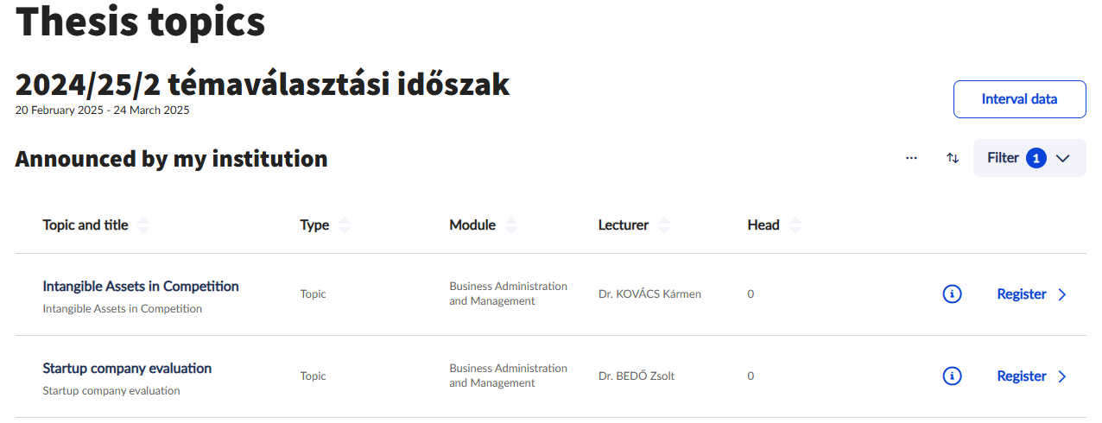

In the pop-up window you must give the **planned title** of the Thesis and upload a short **outline** of the topic in PDF form (**Don’t** write it into the text field, because instructors will read the uploaded file)

*The outline of the topic should be well thought-out and convincing, because in case of over-registration, the instructors will evaluate theses by the abstract.*

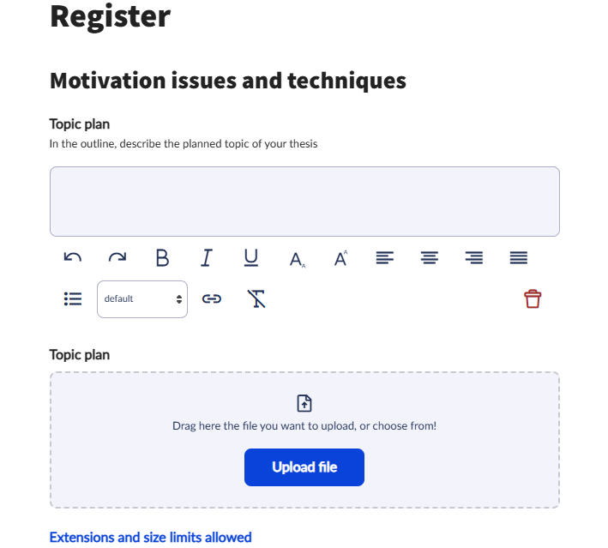

You can choose **three** topics, and you can modify the ranking of registrations after pressing **“Sort registrations”**. On the pop-up window, alteration is possible by moving.



